Early Efforts On Building Setup:

1. First attempt for getting placido reflection was using front camera and displaying placido rings on to the screen of the smartphone. This was unsuccessful because the screen size was not enough to cover the cornea and to get more coverage when we tried holding the mobile close to eye then front camera was not able to capture the cornea correctly.
2. This time we thought of having an cardboard attachment with the smartphone. Below figures display the setup images. This was a simple cardboard with multiple holes in it so that the flash light of the mobile can pass through these holes and the back camera of mobile can capture the reflection from cornea. This setup was also unsuccessful because flash light wasn’t enough and it could at max shine lower half of the setup.

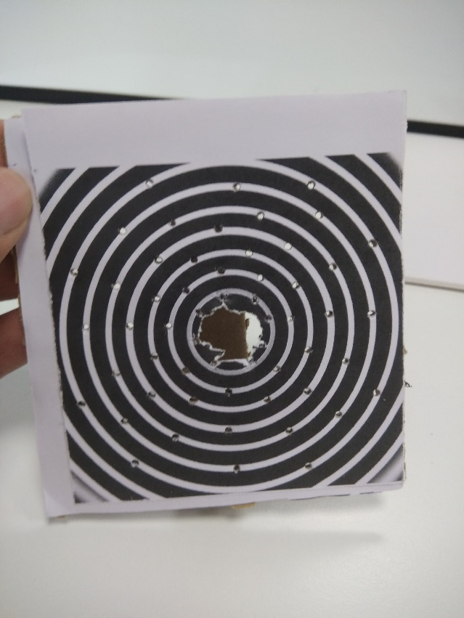 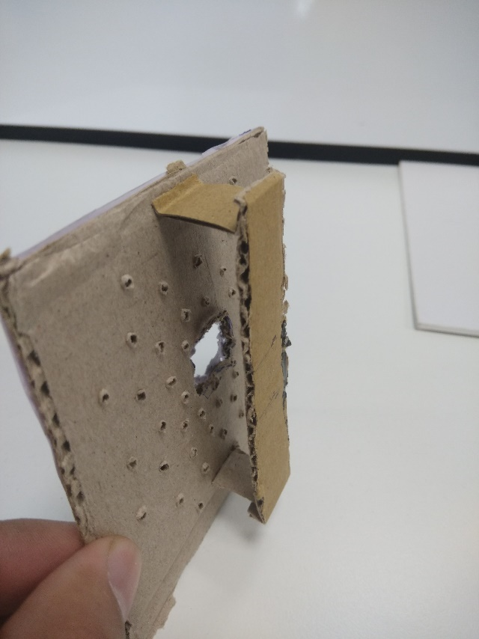

1. This was an attempt with the ambient light since we were not able to find a good lighting solution. Another cardboard setup with printed placido was used to capture in the ambient light. Below figures show the images of setup and resultant image of the cornea. In this case, as seen in the figure cornea had so many other ambient reflection and placido wasn’t clearly visible. We also took images with the same setup in the dark room with mobile flash light (to illuminate rings). Flash light’s intensity was too high which resulted into high diffraction for the bright rings and the rings was not visible, also the flash light was illuminating only lower half of the placido.

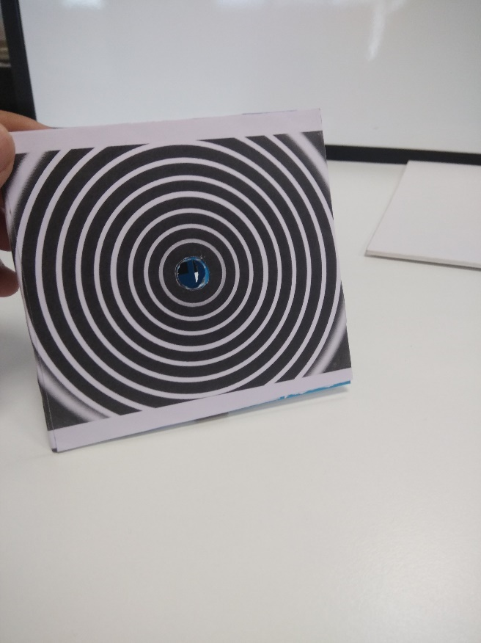 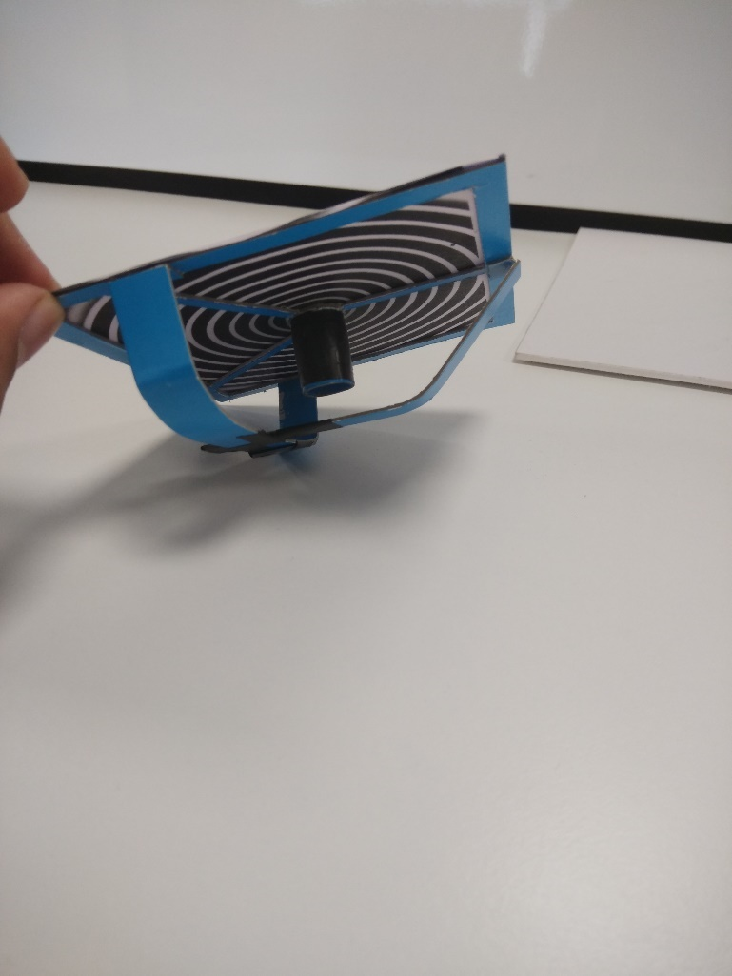

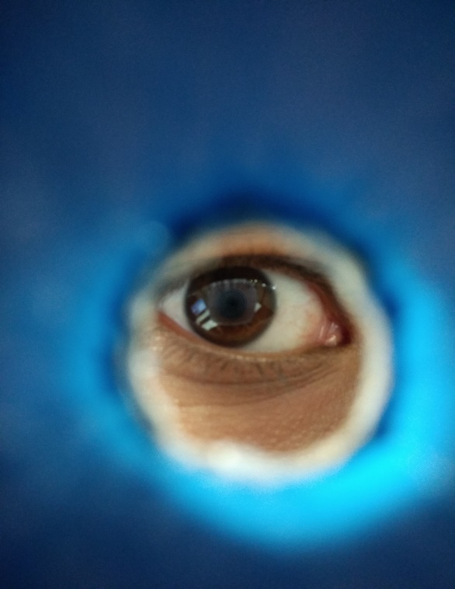 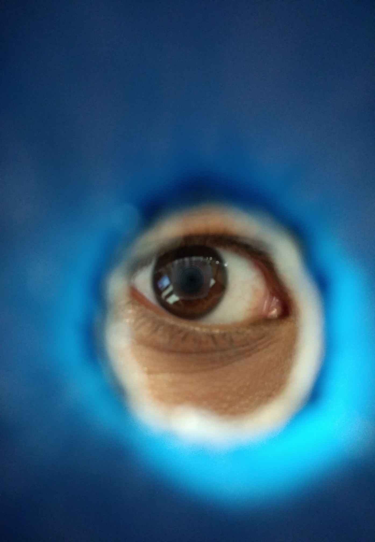

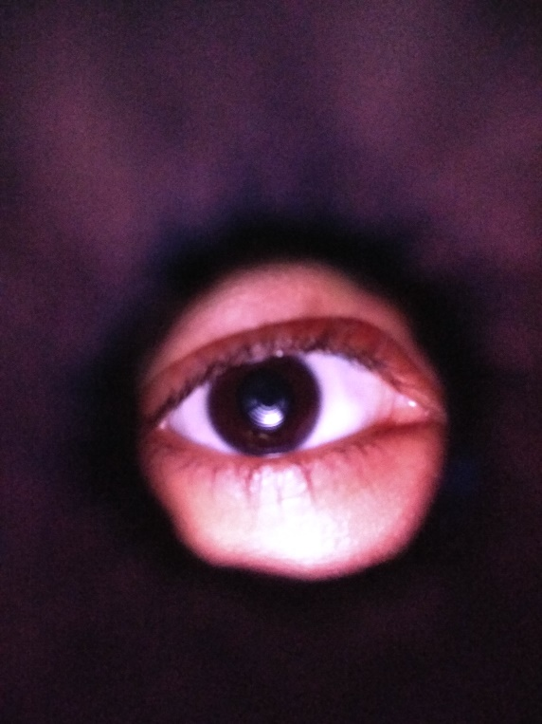 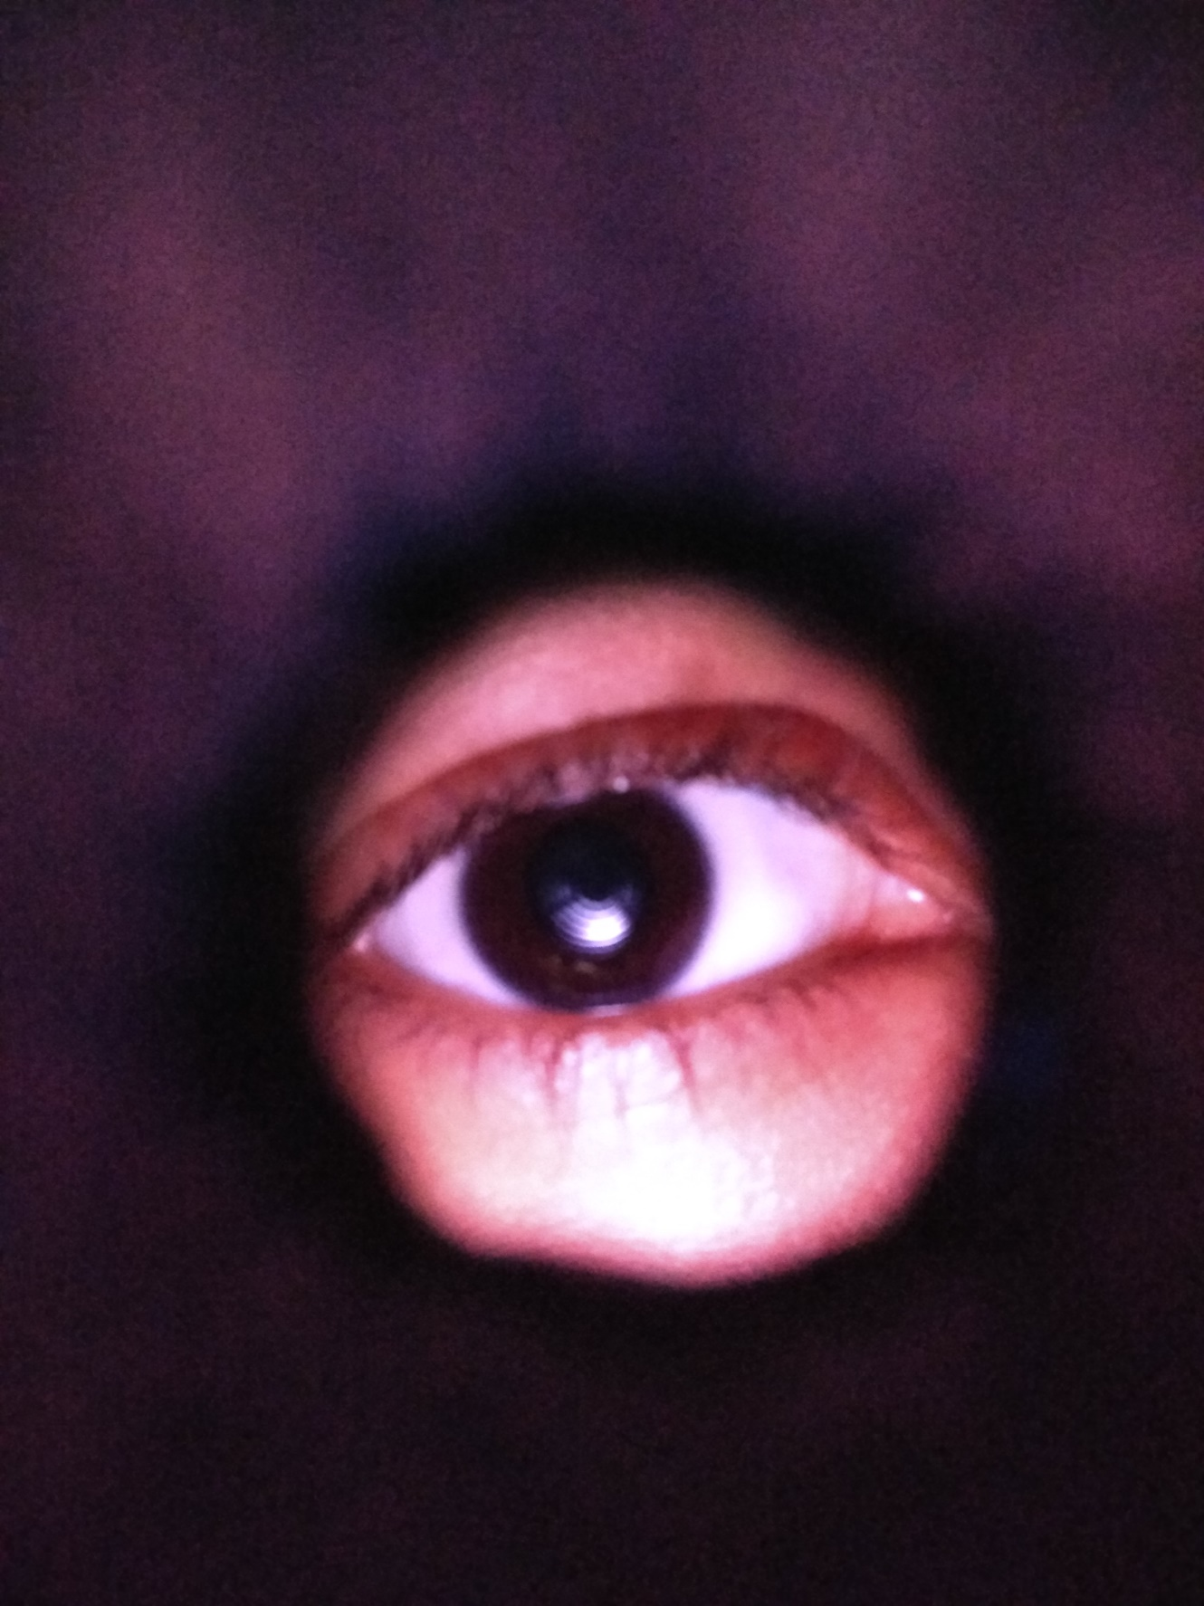

1. Another attempt with two mobile phones, one mobile screen to display semi-circular rings and other phone to capture the image of the cornea with back camera kept near the center of the semi-circular rings. As the image show below, rings were sharp but this will require two capture for lower and upper semi-circular reflection and merging these two image to form a ring will result into registration artifacts.

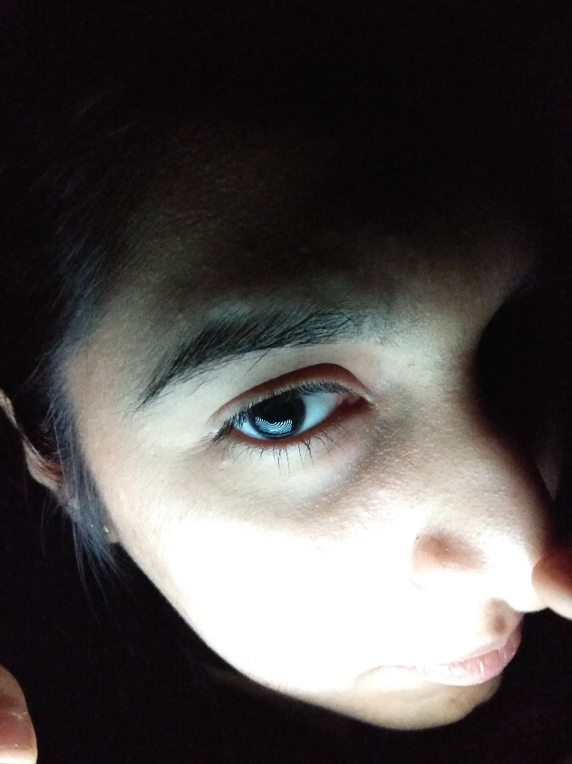 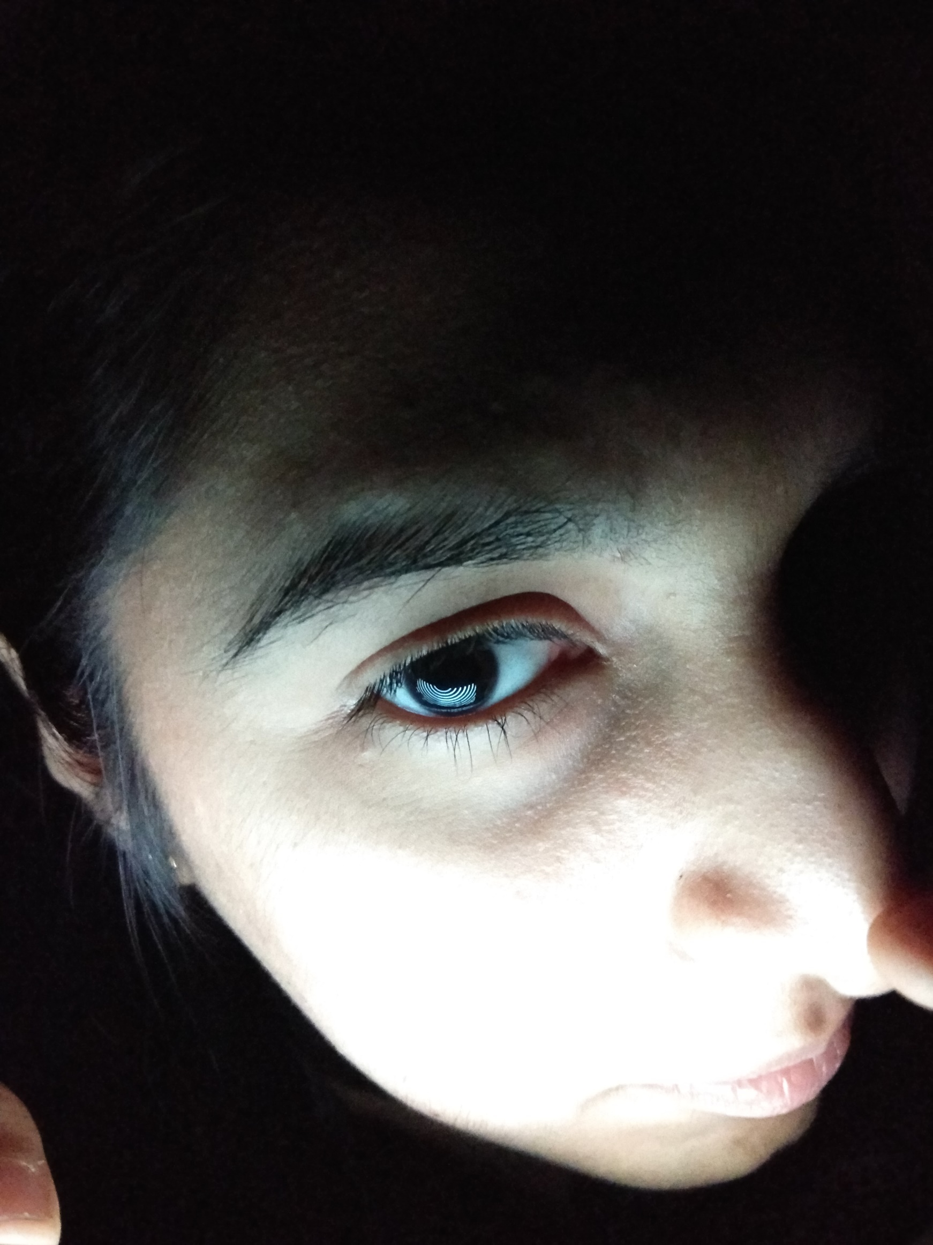

1. Light source was a major problem with all the above setups. Finally, we decided to use extra led lights to illuminate the rings uniformly. I tried to build a cardboard box with LED lights in it, as shown in the figure below. Also I tried to cut the rings in another cardboard which can be pasted on to the LED source, so that the lights will only come out of the empty rings. Figure also display the corneal reflection images with this arrangement. First time we got good placido reflections, but since the placido rings were manually cut, there were artifacts on the edges, but lead to the idea of 3D printing.

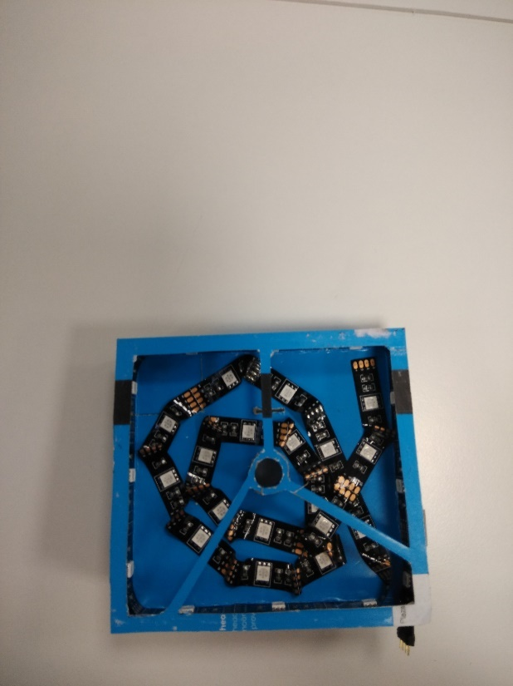 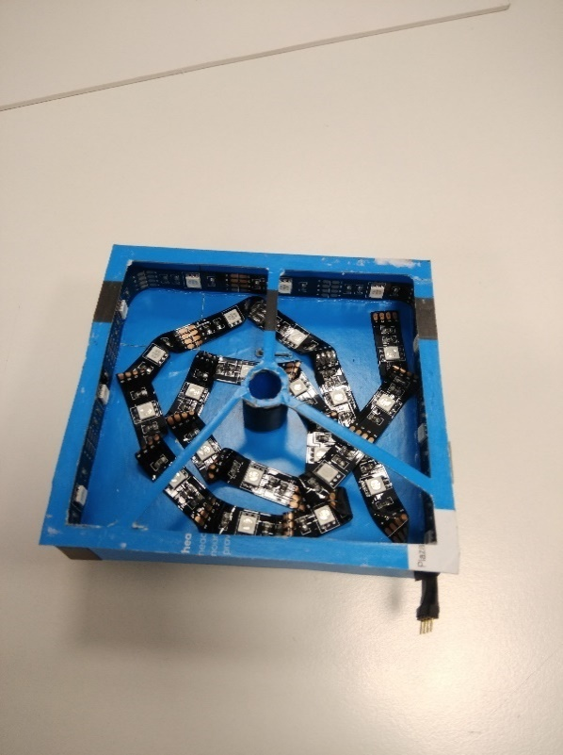 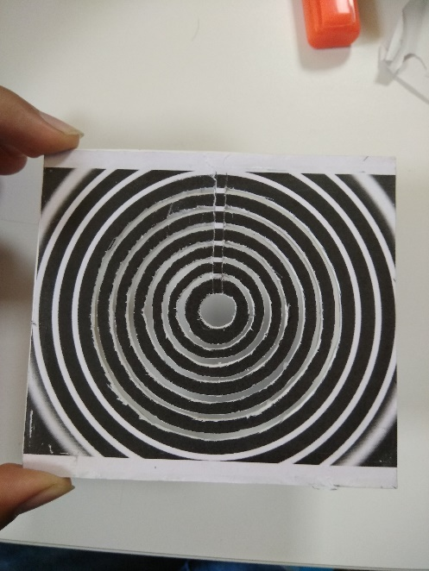

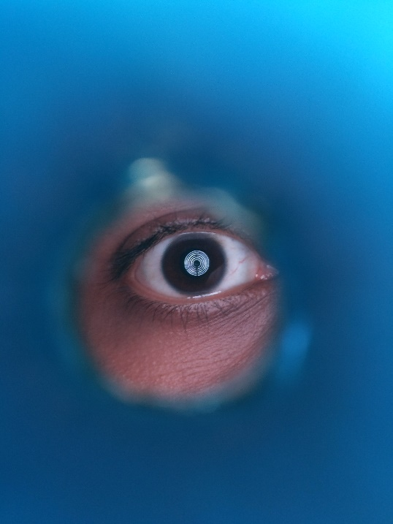 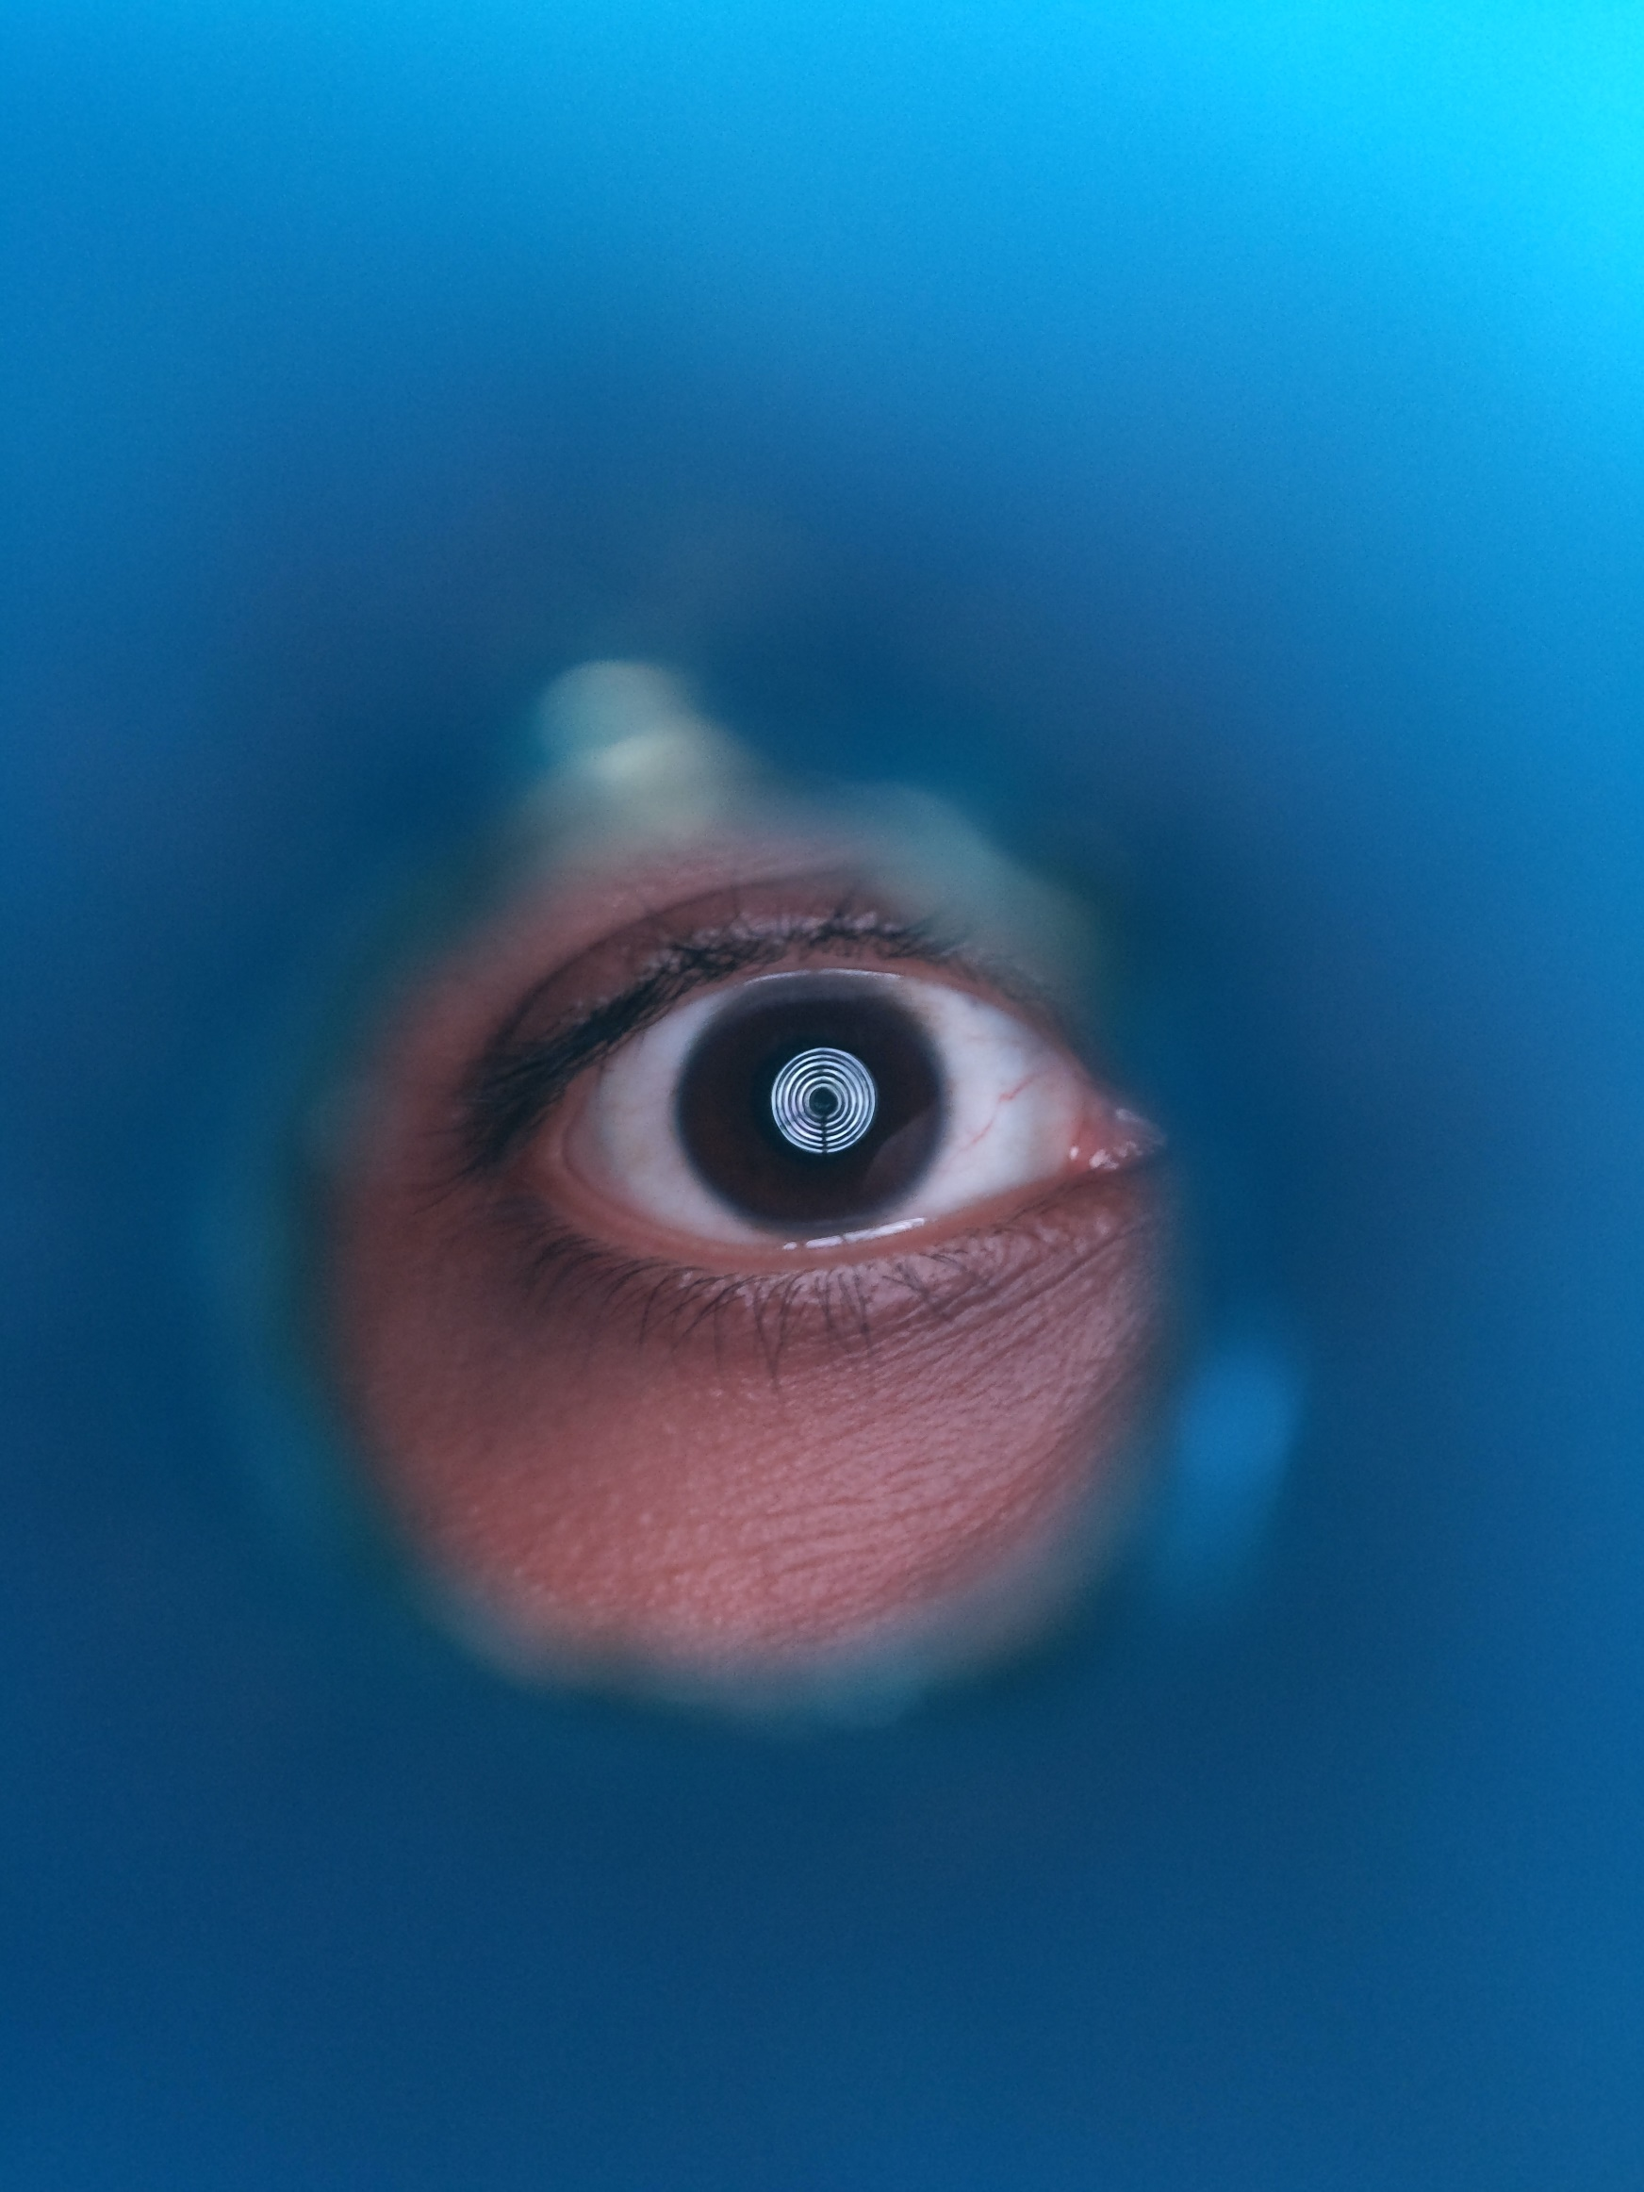

1. This time we decided to get a 3D printed placido disc which was used with previously made LED light source. Figure show the image of the placido disc and the capture setup. We can see the coverage on the cornea is not good (all the rings are concentrated in the center). Also the 3D print material was of white color, so edges were not very sharp. It was a flat disc, and to get more coverage on the cornea, disc has to be kept closer to the eye, but keeping the setup very close to the eye, mobile camera was not able to focus (distance was beyond the minimum focus of the camera). This lead to the design of conical placido disc.

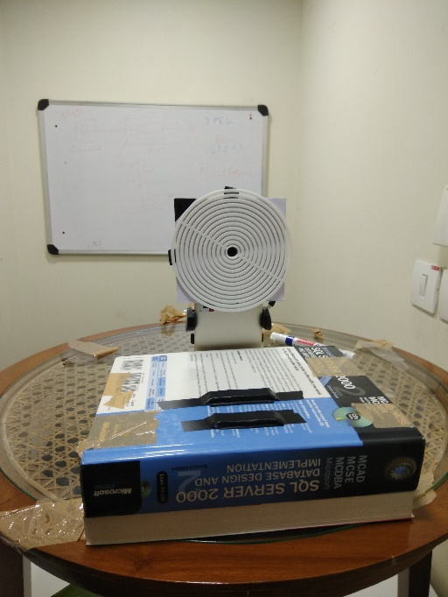 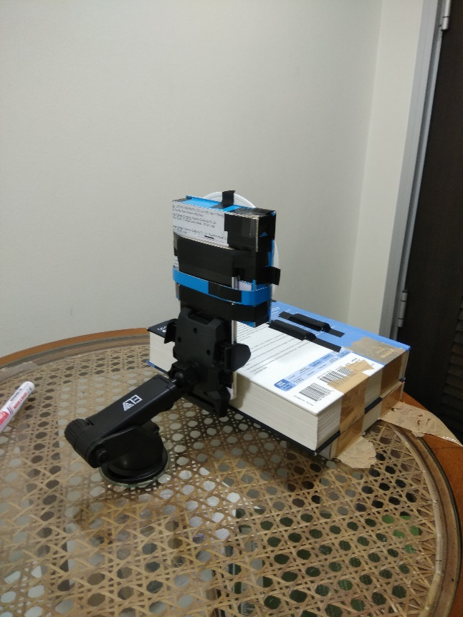 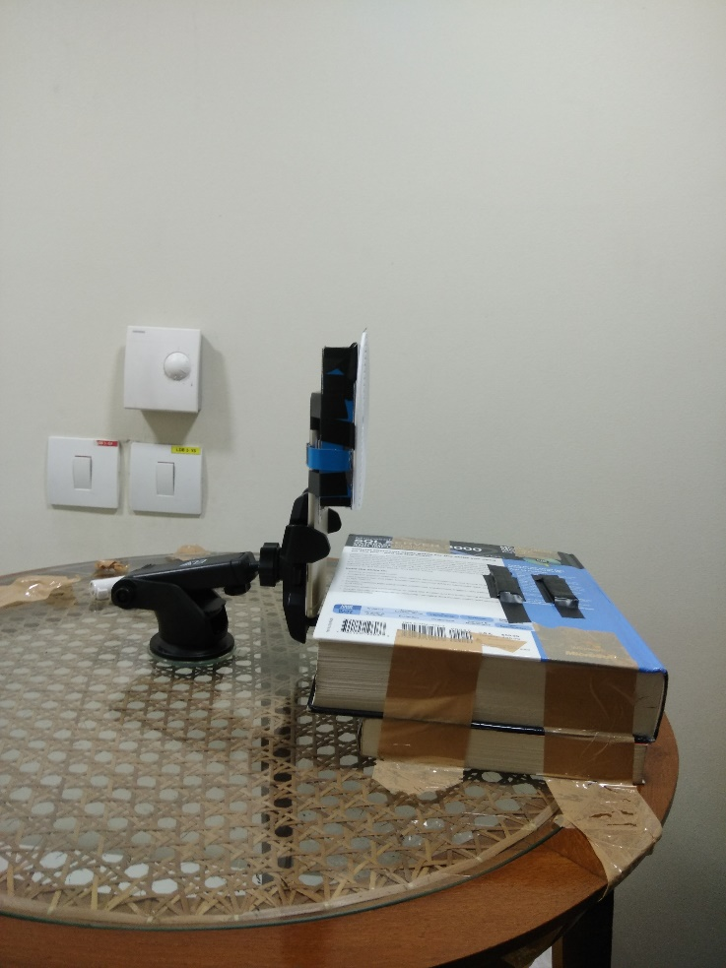

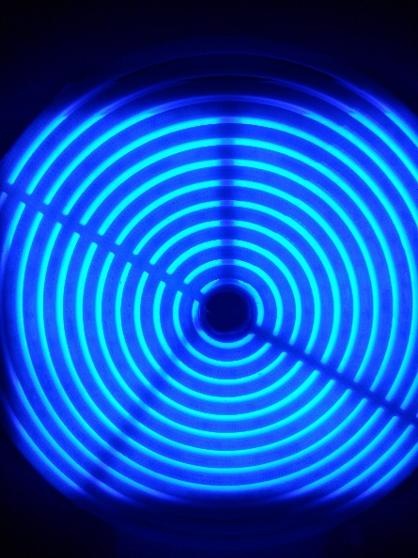 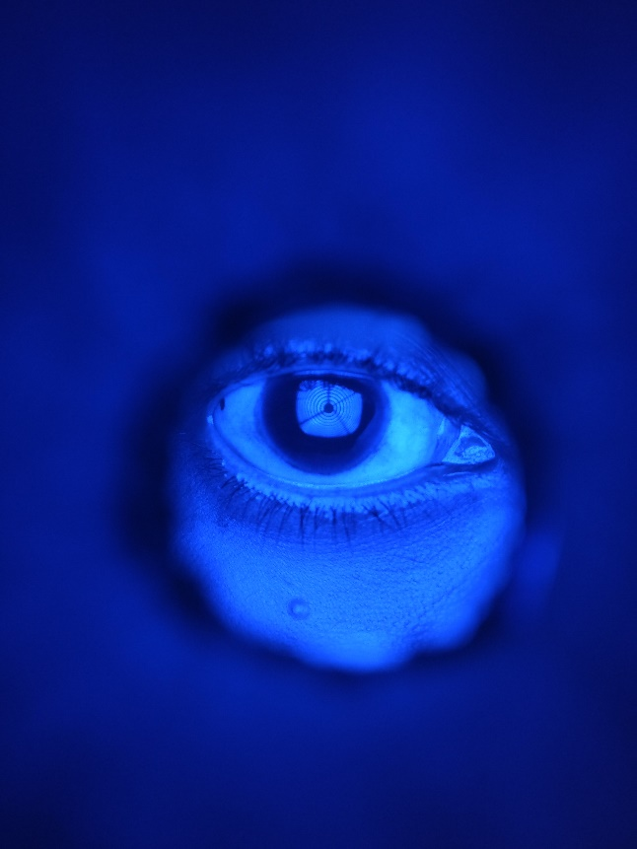 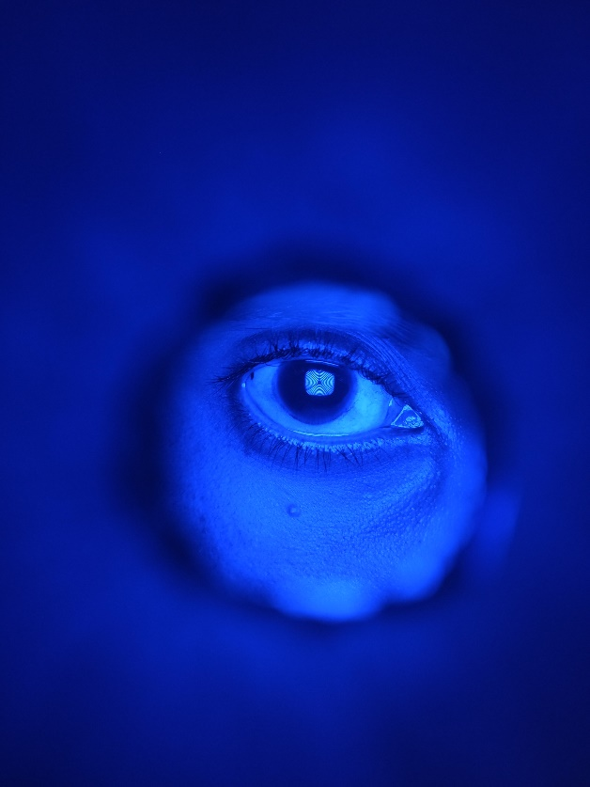

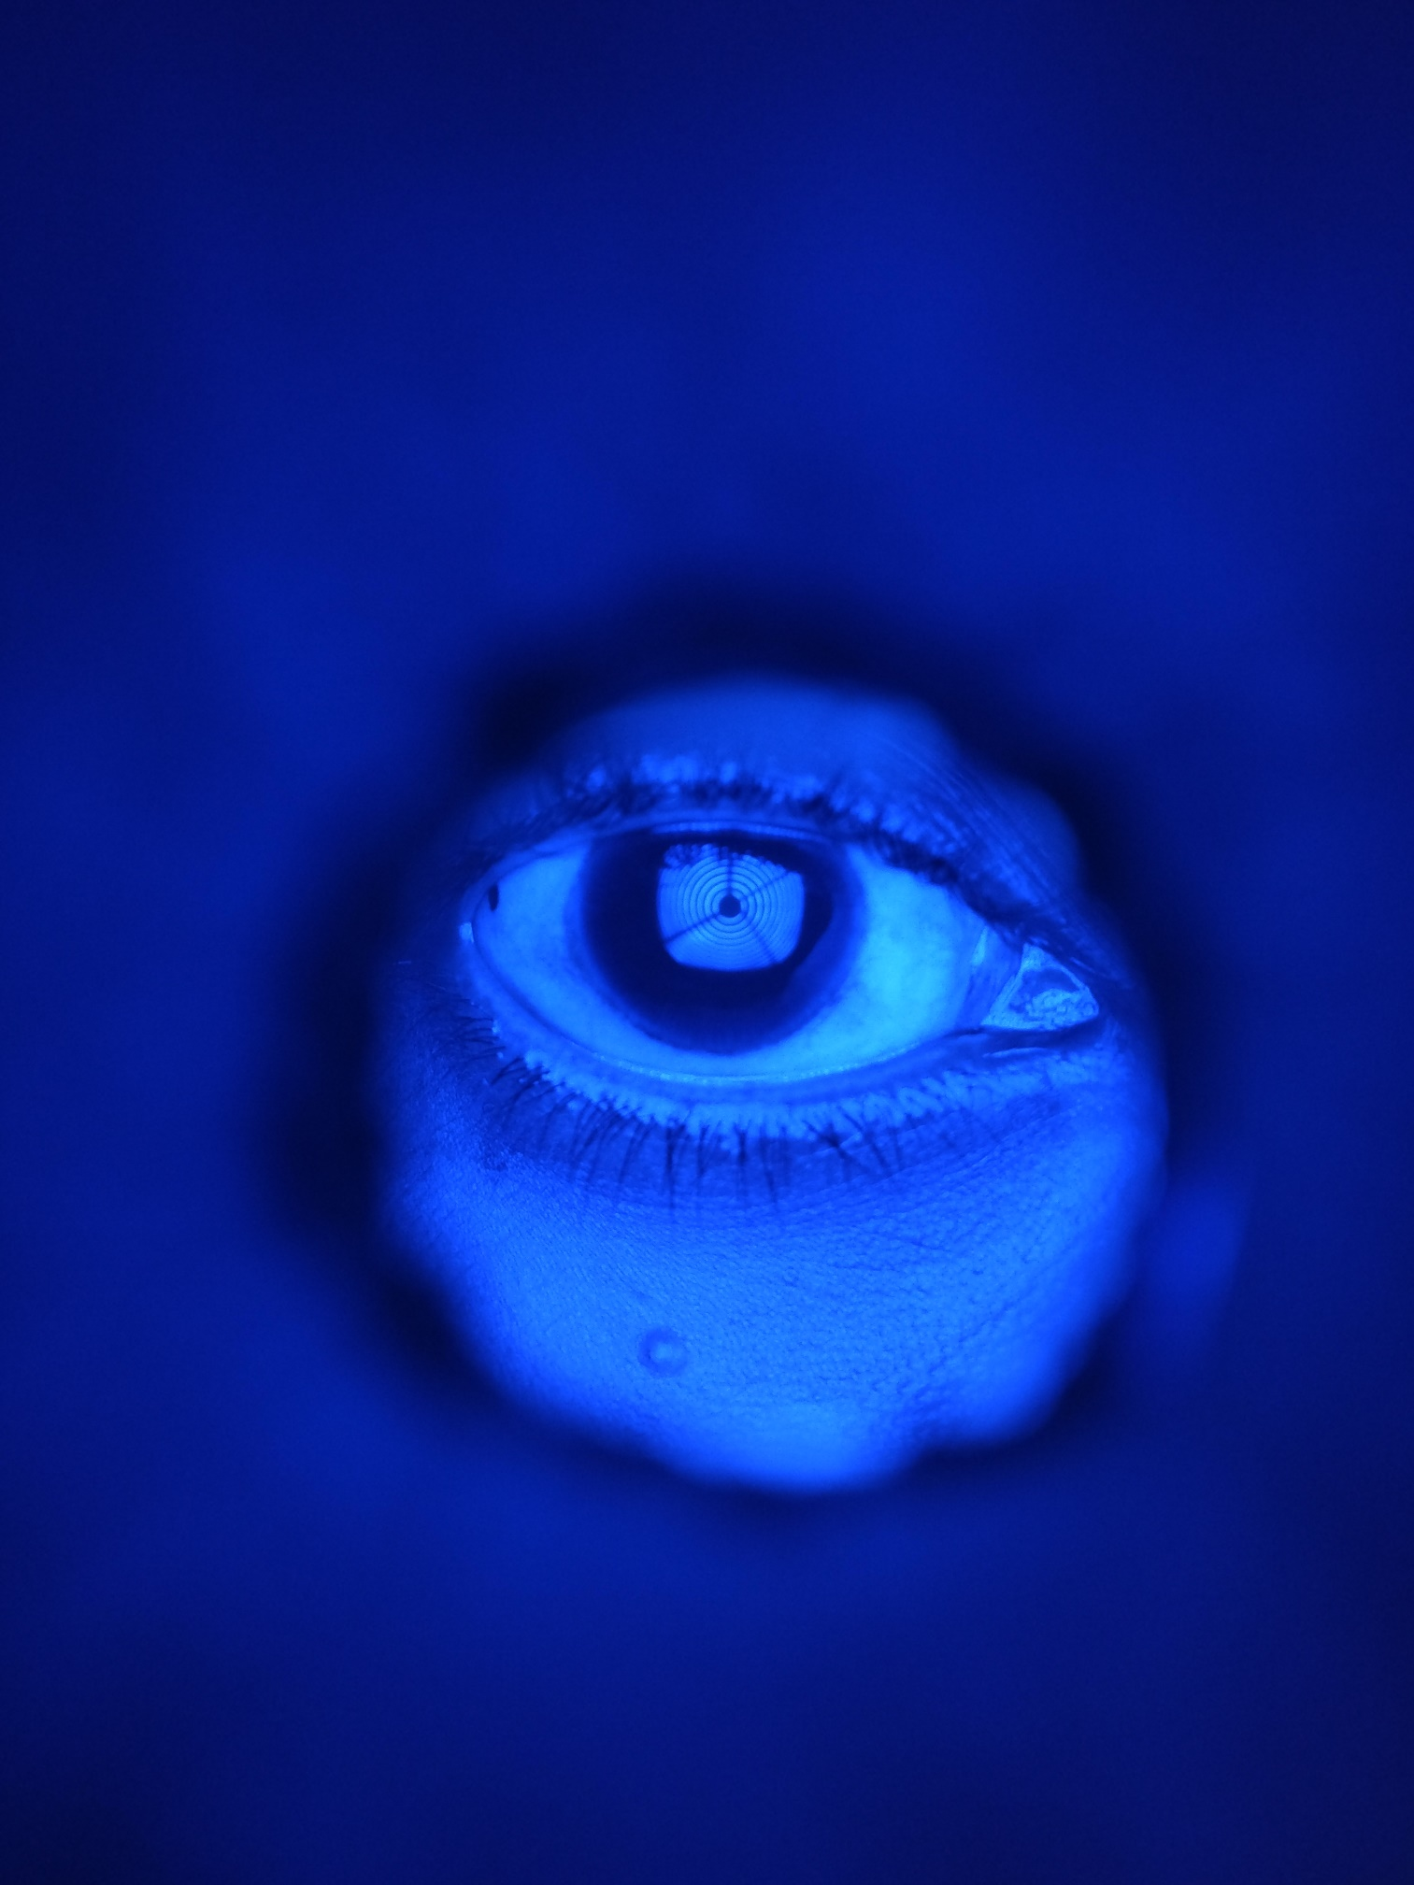 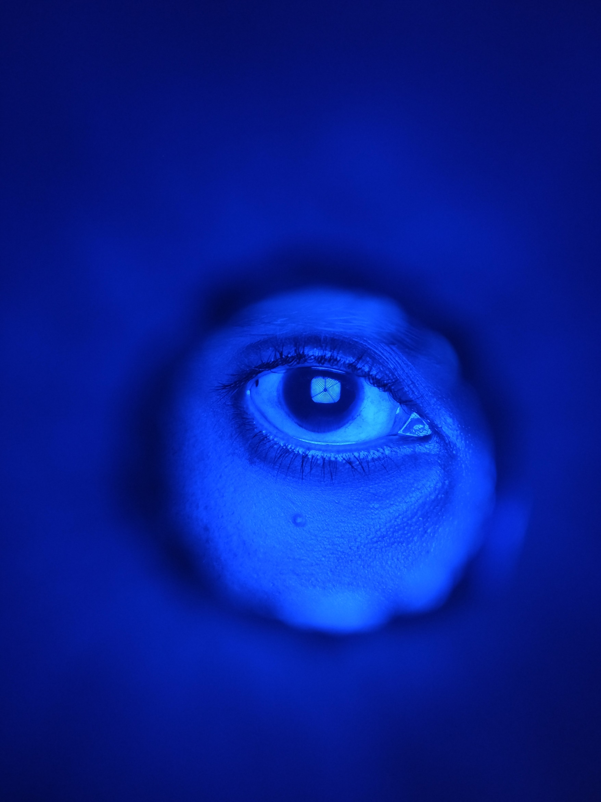

1. A conical 3D printed placido was used this time with the same LED light source. First, we tried to diffuse the LED light source with plain paper and tissue papers, but the diffused light was non uniform across the rings. Later butter paper worked well as a diffuser. Finally, we arrived to best placido setup till now. Following are the images of the setup and the reflection from cornea.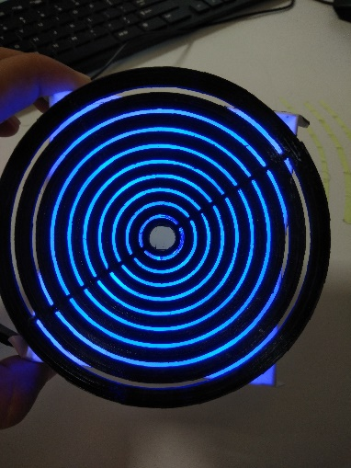 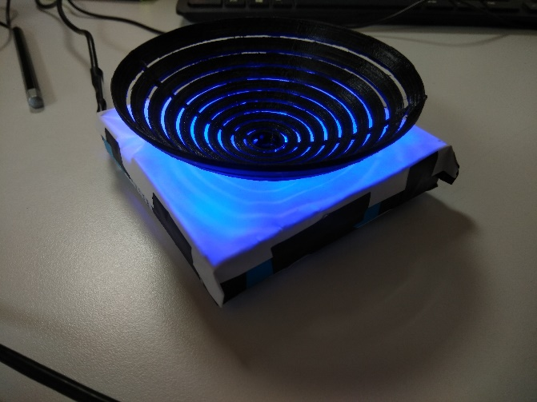 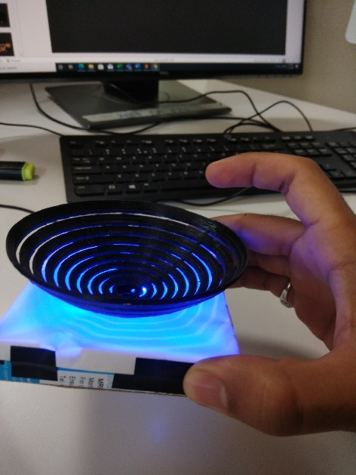 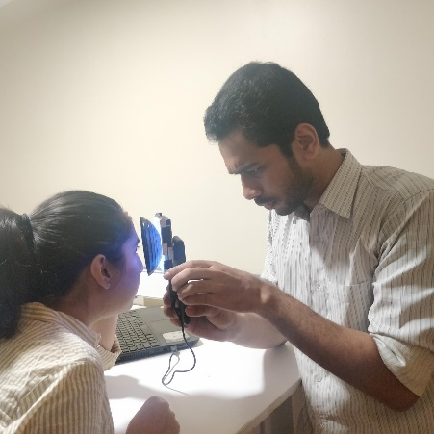 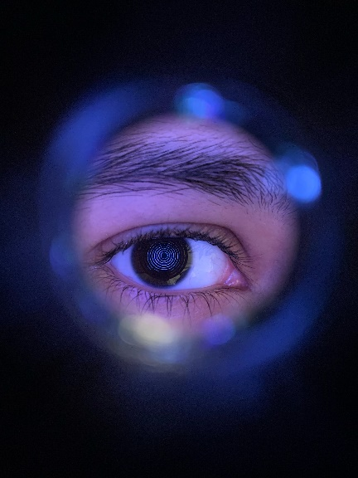 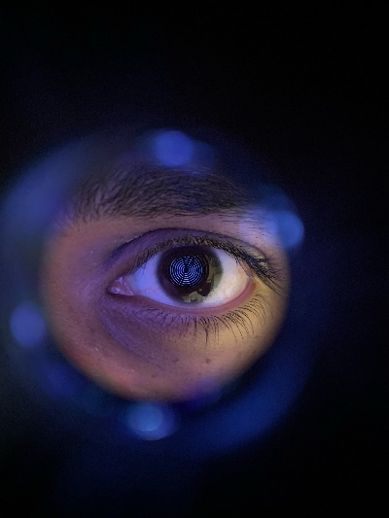

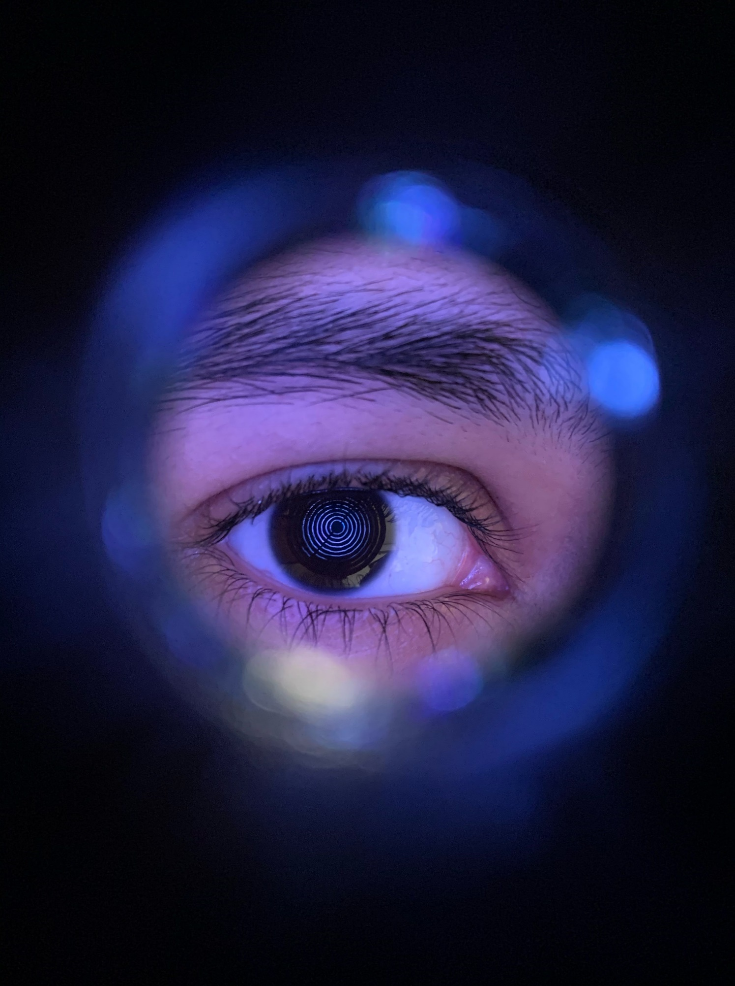 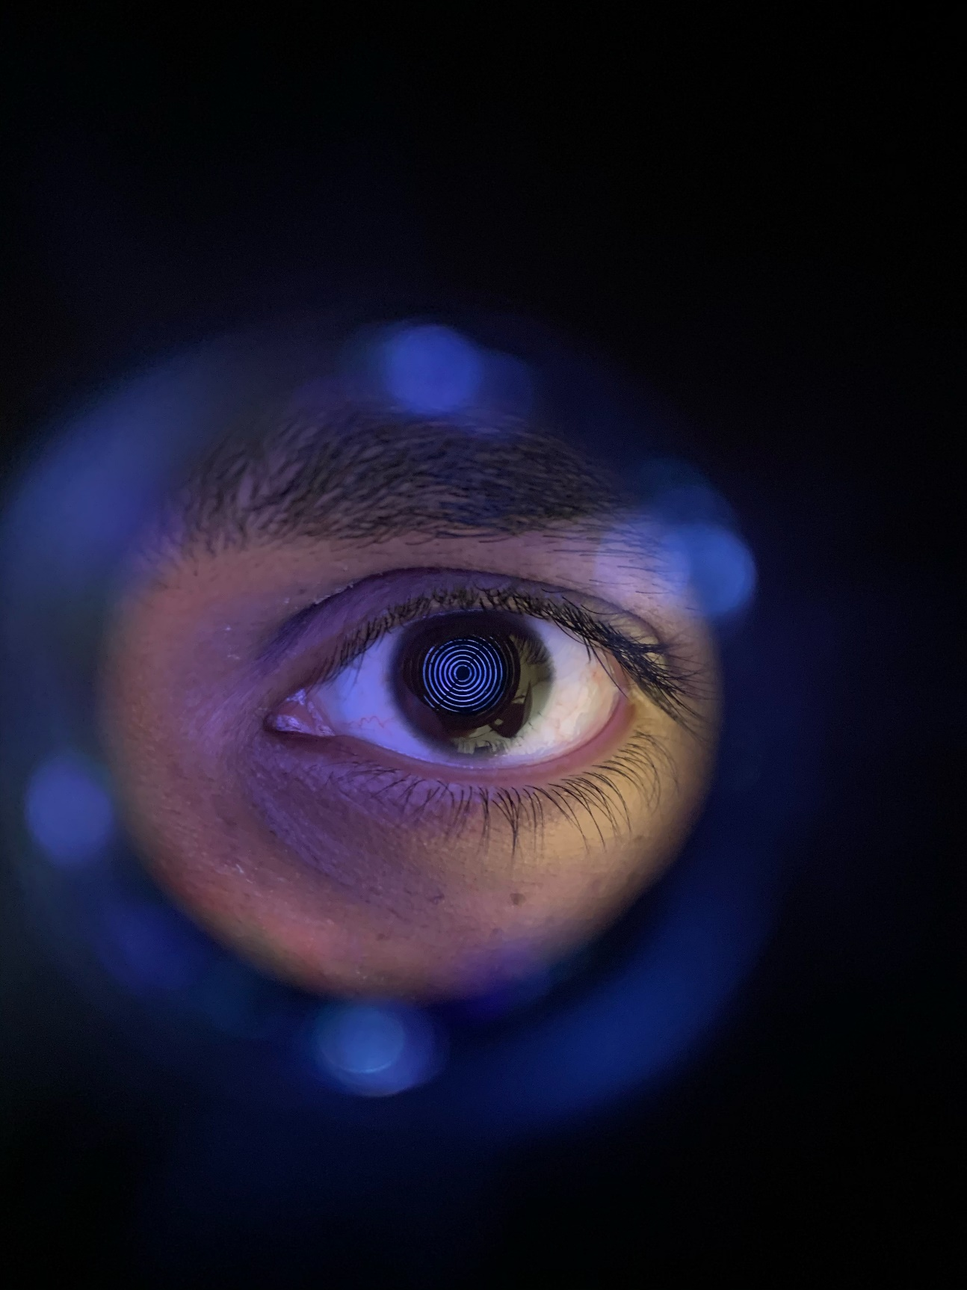

Image Processing Pipeline:

After capturing the image with placido setup, this pipeline(program) takes input as the cropped image of the cornea with placido reflection. Then we apply different kernels to get rid of noise in the image and finally obtain a clean edge map of placido rings. This edge map is then used to find the center of rings and the connected components on the rings. Then these connected components are merged if they lie on the same ring. Finally, we will have each edge point in the image assigned a ring label (ring number). Below is the detailed explanation of each steps involved.

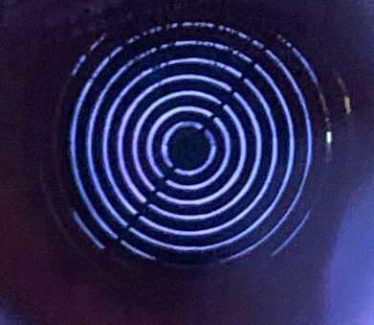 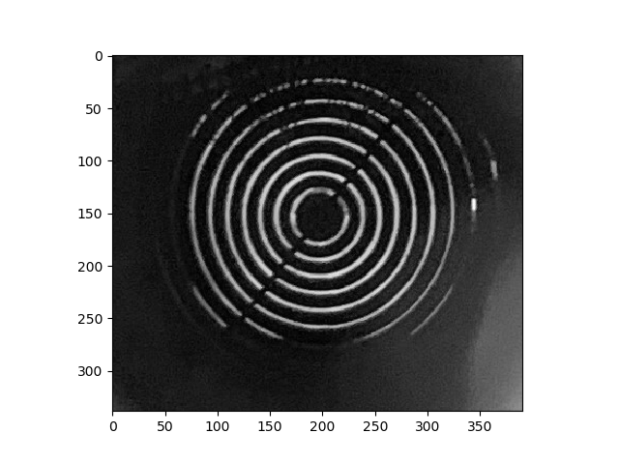

Figure 1: Cropped input corneal reflection image. First is colored and second is the gray-scale version of the same image.

Steps:

1) Gray-scale image as input.

2) Find Laplacian (input - gaussian blurred input).

3) Add Laplacian to input (Laplacian+input).

4) Apply morphological opening operator (Erosion followed by Dilation).

5) Apply median blurring to remove unstructured noisy points.

6) Apply Canny edge detection.

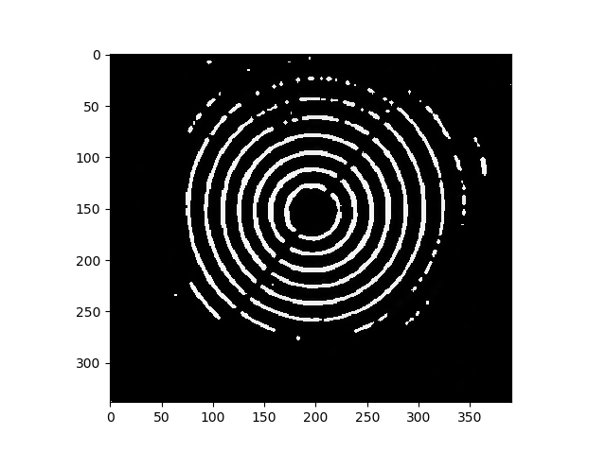 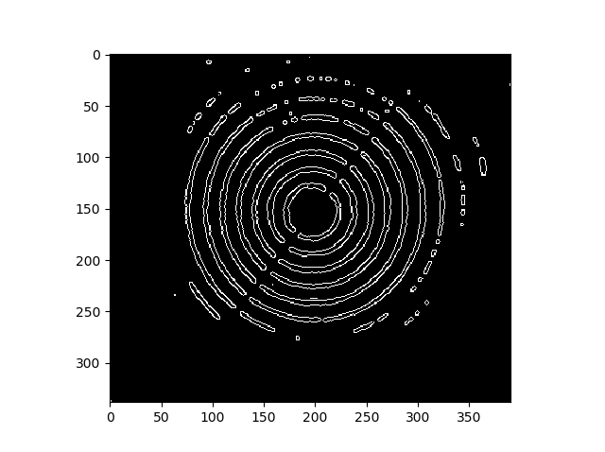

Figure 5: Enhanced gray-scale Image. Figure 6: Output of Canny edge detection on median blurred image.

Estimation of the center of co-centric rings:

To estimate the center of all the co-centric rings we rely on the inner-most ring. We fit a circle using “Hough Transform” for a small range of ring radius between 5pixels to 35pixels (range can be adjusted based on the resolution of the input image.), this defines the search space for finding a circle. Hough transform return the obtained circle i.e. coordinate of the center and radius. This coordinate is further used in labeling the rings in the image. Below image demonstrates the detected circle.

Why do we rely on inner-most ring: Because the outer rings can be distorted due to eyelids, eyelashes or Keratoconus.

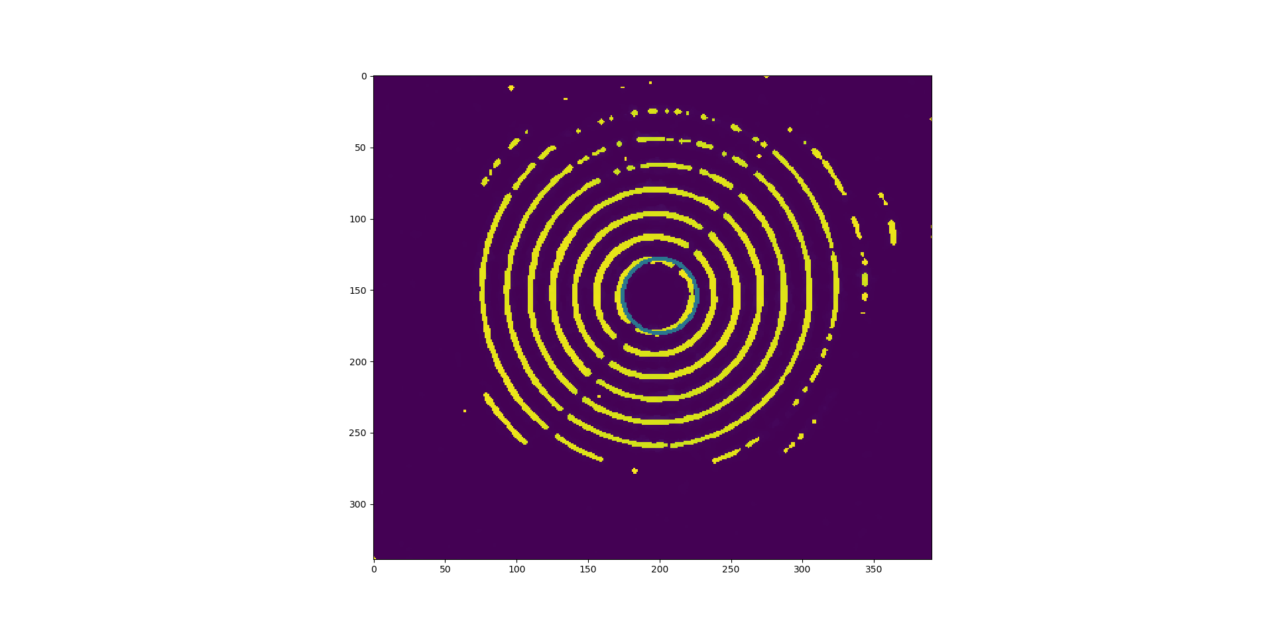

Procedure for labeling rings:

*Objective:* is to assign each edge pixel in the edge map computed above, to one of the ring number.

*Challenges:* Because of the eyelashes, rings might be broken, and part of cornea can be covered by eyelids. So, the input image might not be having complete ring or a completely connected rings.

*Solution:* We first compute the connected components (curved segments) in the edge map using DBSCAN algorithm. DBSCAN algorithm takes input as coordinates of the edge points and a tolerance value (maximum geometric distance between two points to define connected points) and output the segments of connected points. These segments are then used to form a ring. Algorithm for connecting the segments to form a ring is explained below.

1. For each segment, find the two end points of the segments and represent them in polar coordinates with respect to the center of the co-centric rings i.e. radius w.r.t center and theta (angle) w.r.t horizontal axis.
2. Define the criteria to identify whether two segments are adjacent to each other on the same ring. Criteria used is-

* Compare the end points of the two segments, i.e. find the difference in radius and theta, if the difference is within the threshold (2pixels for radius and 0.2 radian for theta) then these two segments are adjacent otherwise not.
* *Note:* we could use the criteria as average radius of each segments instead of relying on end points, but that might fail in case of cornea with Keratoconus because ring radius will vary at different meridian.

1. Define a graph, where each segment is a node and the edge between two nodes represents that corresponding segments are adjacent on the same ring.
2. Find the connected sub-graphs in the above graph using Depth First Search (DFS)
3. Each connected sub-graph represents a ring.

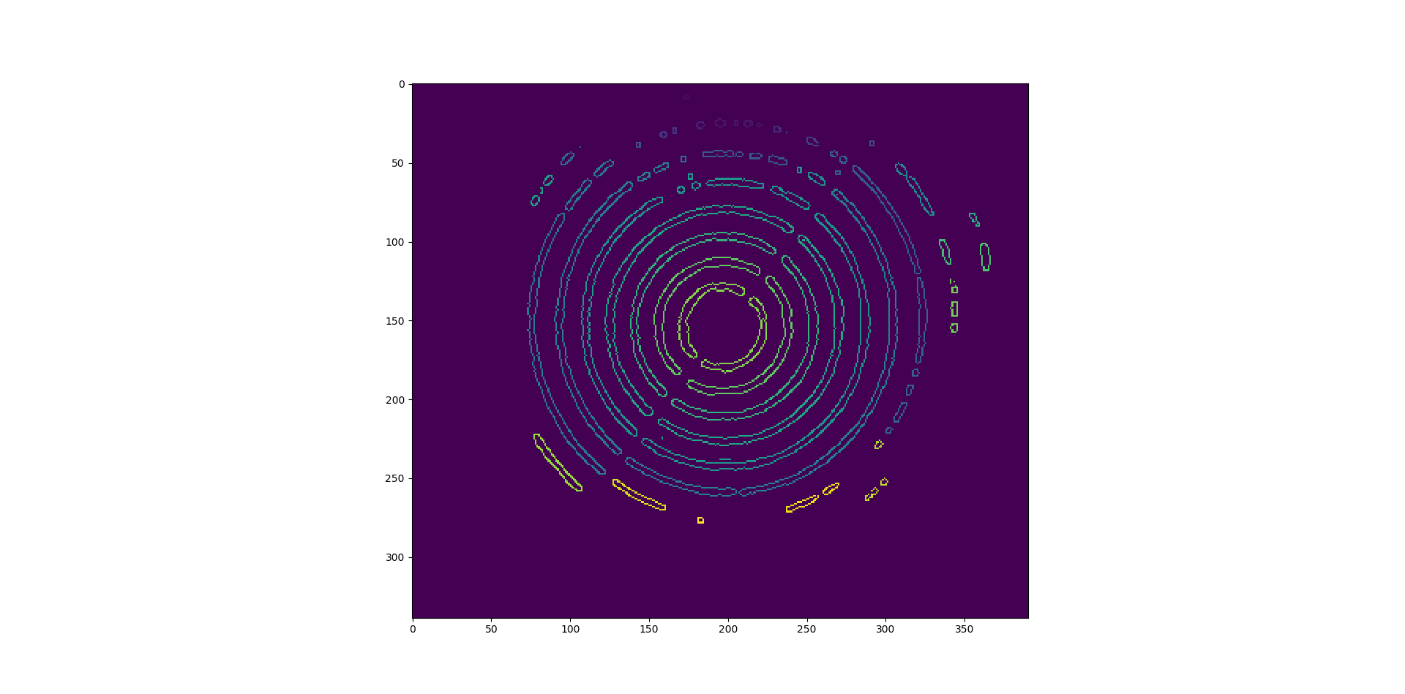 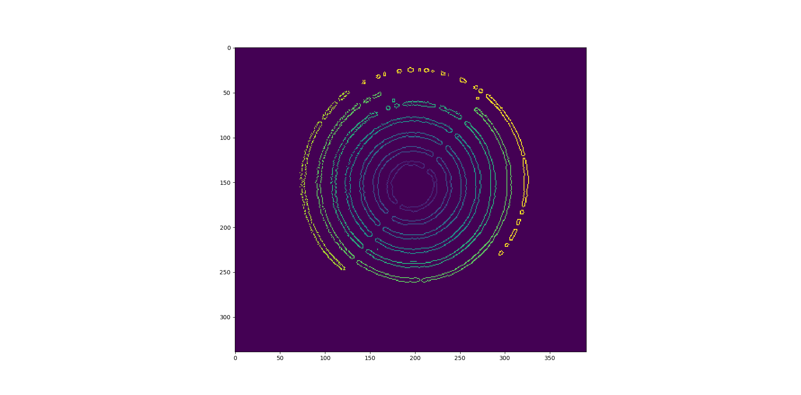

Figure 7: Segments computed using DBSCAN Algorithm Figure 8: Shows the labelled rings using above algorithm.

**Corneal Elevation Estimation:**

1. Derivation for modeling reflecting surface:

In the figure below, following are the notations used.

**Alpha (α)**: Angle between normal of the corneal surface at reflection point and optical axis.

**Theta (θ)**: Angle between reflected ray and optical axis.

**Radius (R)**: Radius of the spherical reflecting surface (assuming cornea as sphere).

**d1**: Distance between camera center and image plane.

**d2**: Distance between camera center and point light source.

**d3**: Distance between point light source and apex of the reflecting surface.

**H**: Distance of the point light source from the optical axis.

**M**: Distance of the reflection point from the optical axis.

By solving the equation 1,2 and 3 shown in the figure below and using the taylor series expansion for ‘cos(α)’, we get the equation for ‘α’. Alpha is dependent on ‘R’,d1-3 and ‘H’. We took the following assumption to solve for ‘α’; a) Among the dependent variables ‘R’ is unknow to us, so took ‘R’ as the average radius of the cornea b) ‘α’ is small i.e. we ignored the third order terms for ‘α’ in the equations.

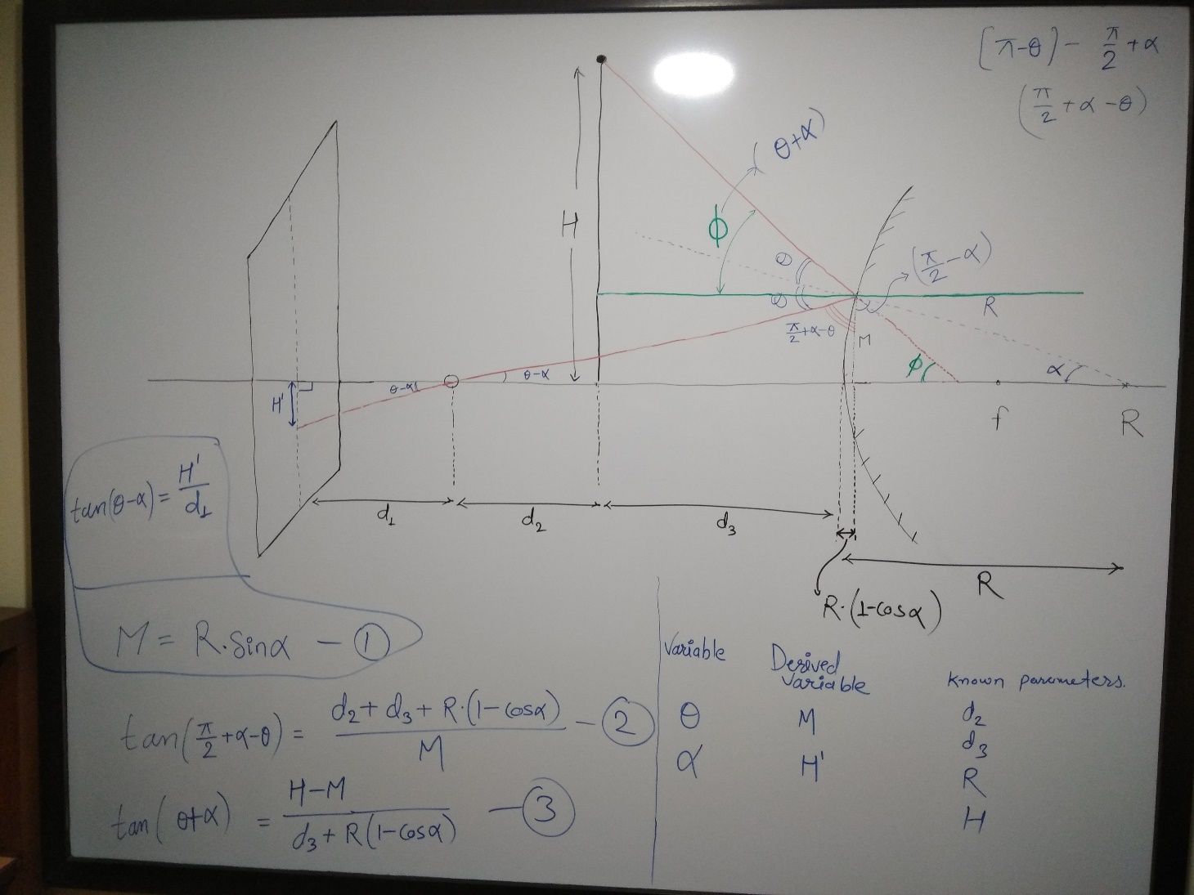

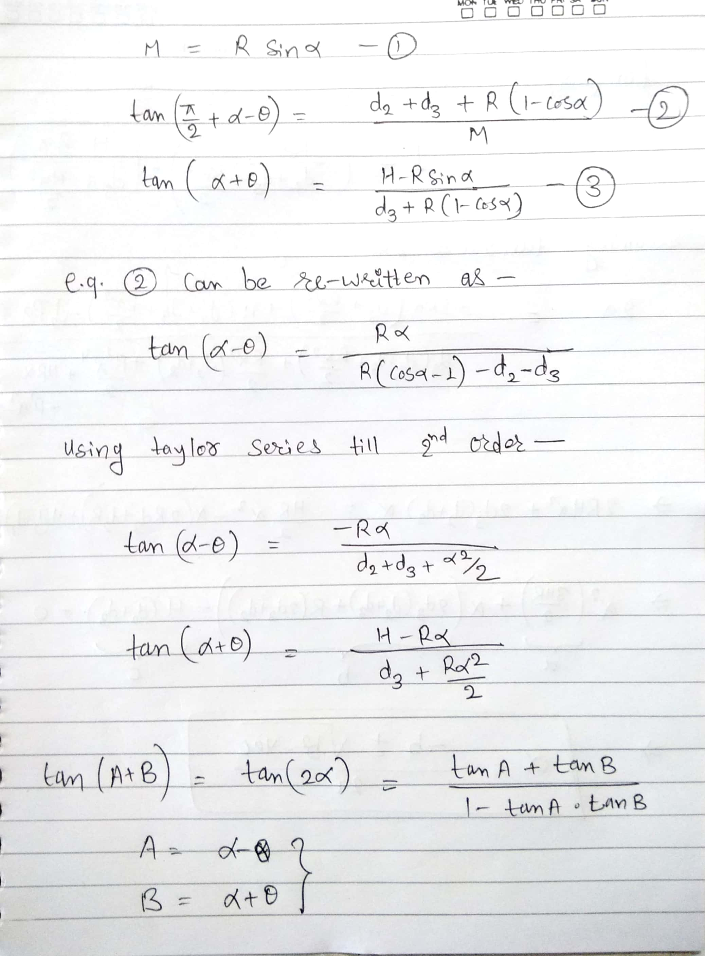

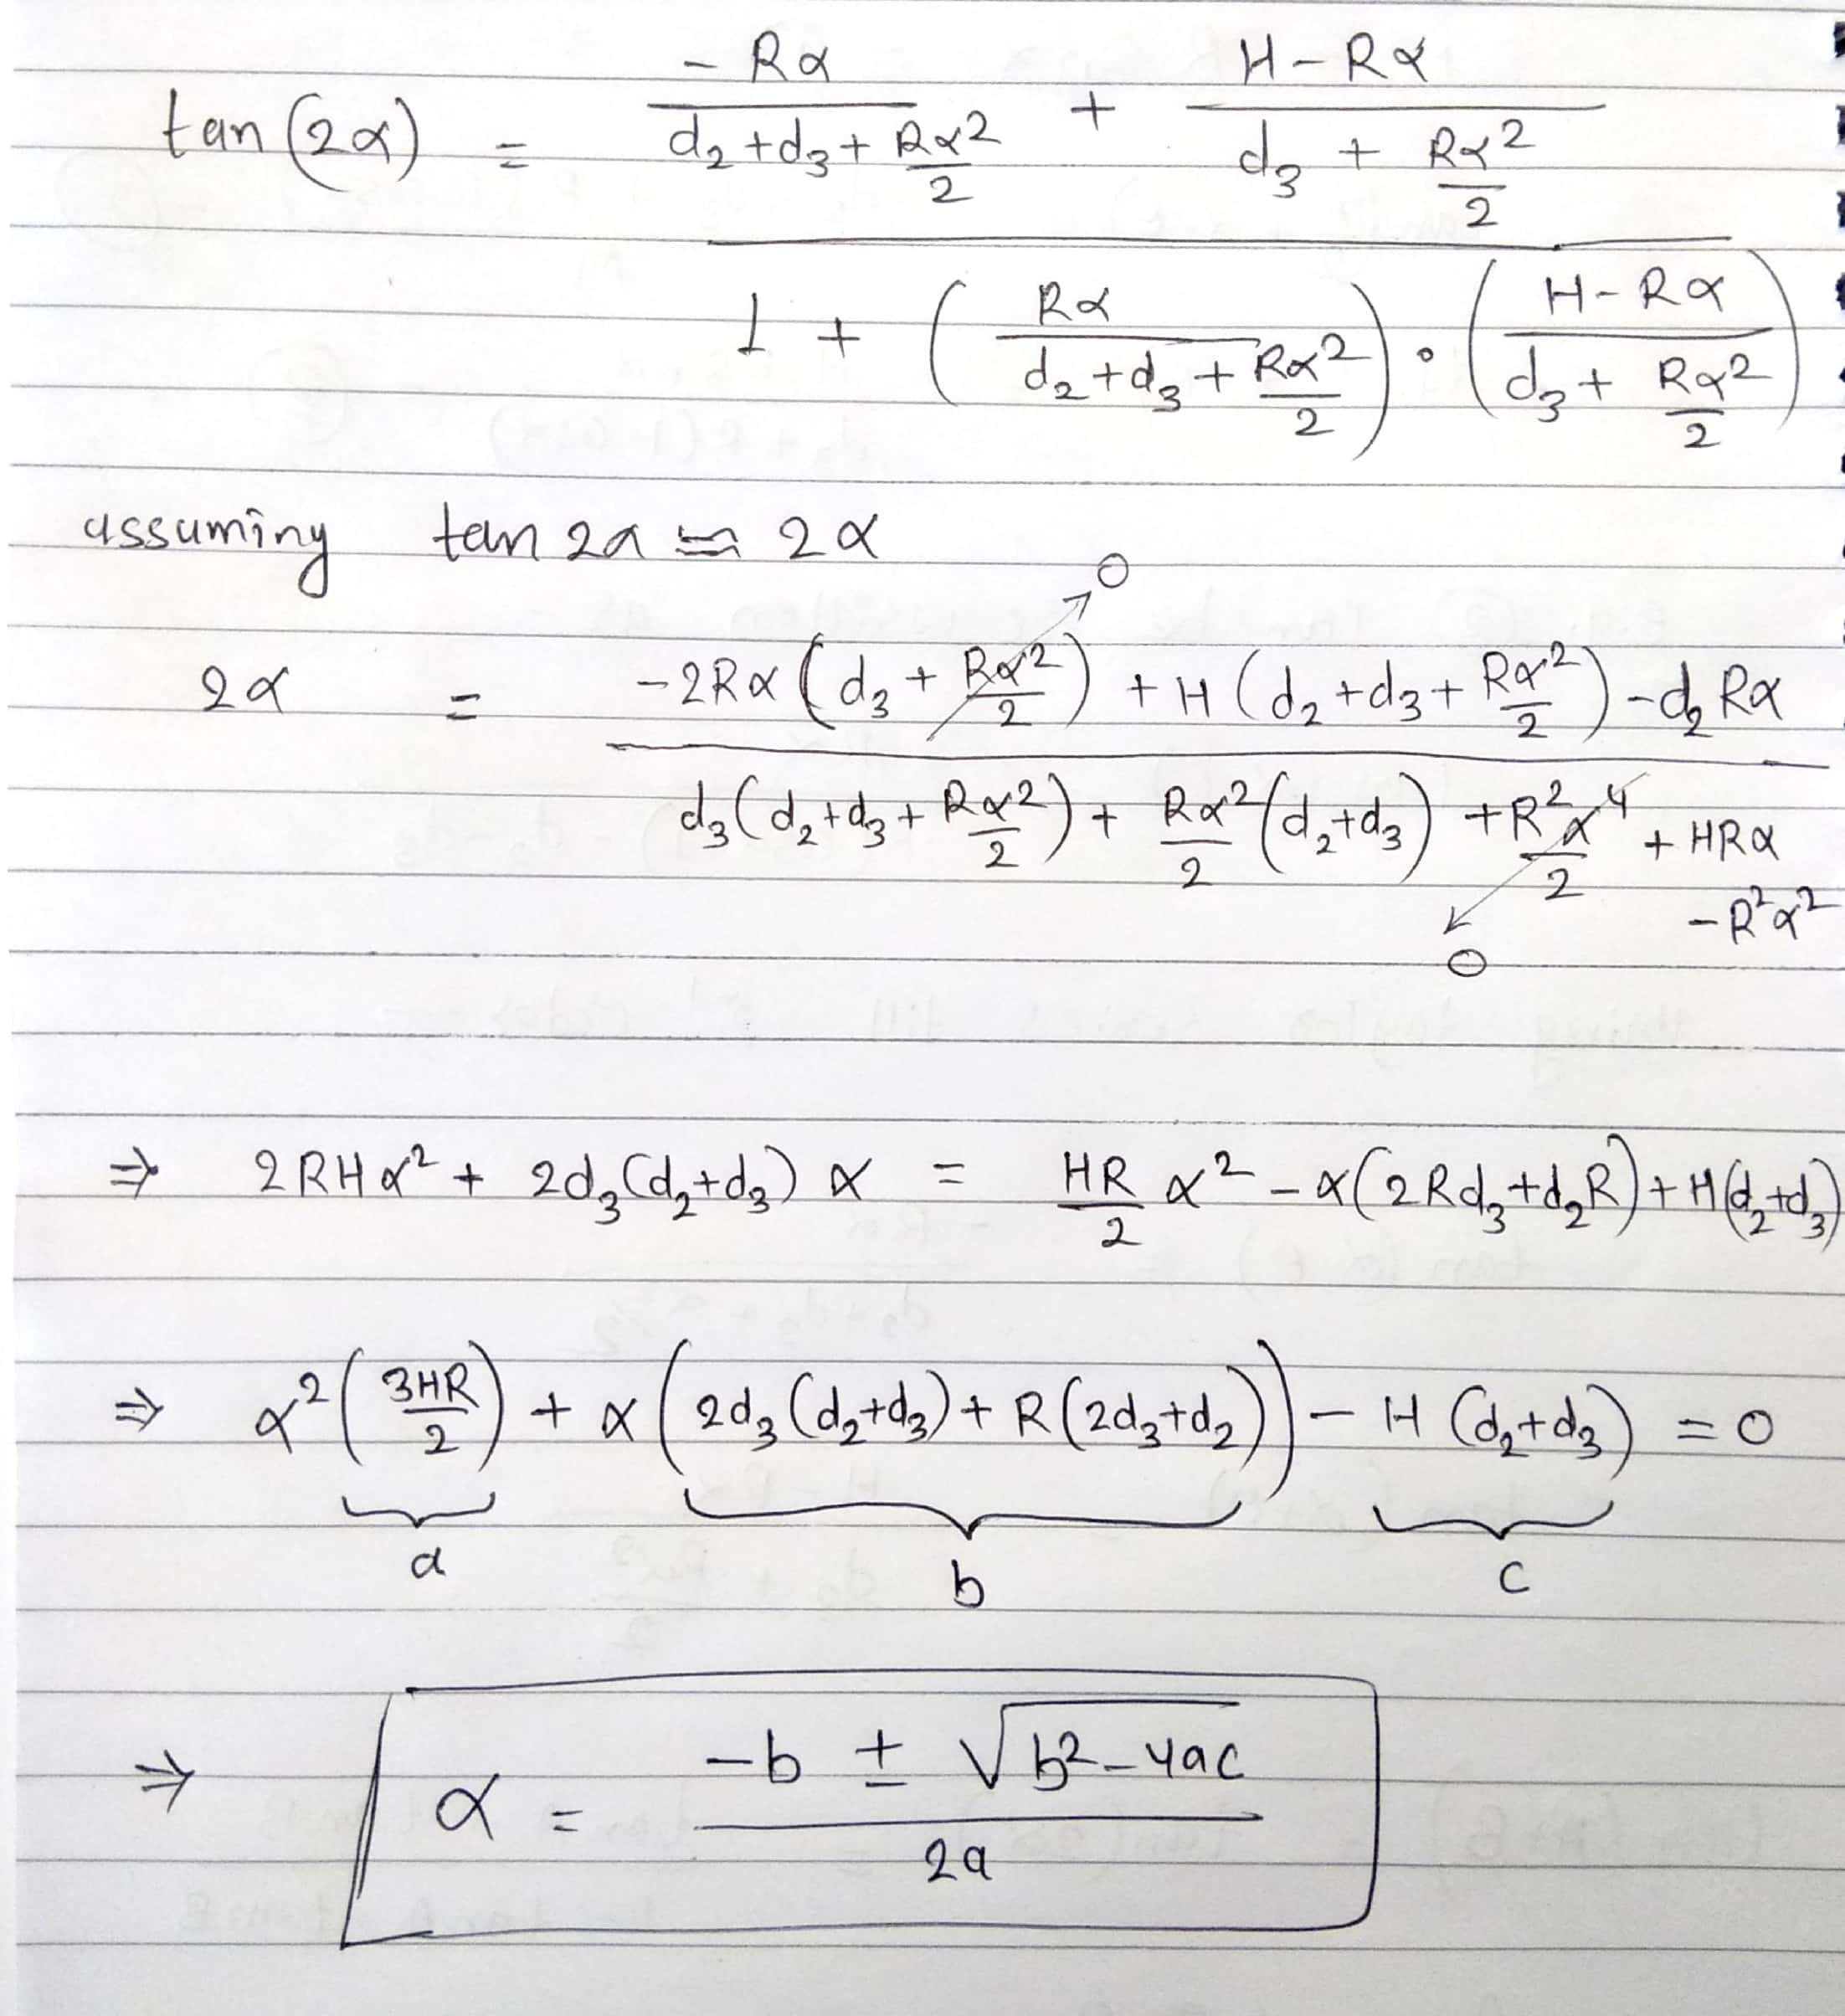

1. Second approach for modeling corneal surface([link](http://pi.math.cornell.edu/~rand/randpdf/keratom.pdf)).

We referred to previous work by Rand et al. ([link](http://pi.math.cornell.edu/~rand/randpdf/keratom.pdf)). They assume the cornea as a spherical surface and tried to approximate the observed cornea as perturbation from a spherical surface. In their work they use the orthographic camera assume (i.e. only the light rays going parallel to the optical axis will be captured on image plane), which does not hold for smartphone camera in practice.

1. Third approach for estimation of corneal elevation.

PaperTitle: Improved method for calculation of corneal topography for any photokeratoscope geometry.

This was the third approach for estimation of corneal elevation using double iteration process proposed in the paper. Paper uses few relations between different parameters of the setup and placido image for the estimation of elevation. When using the steps mentioned in the paper, result was not as expected, and it was difficult to track the error because of multiple parameters and relations which was not explained theoretically.

1. Fourth approach using calibration of the device.

Paper Title: Open-access operating algorithms for commercial videokeratographer and improvement of corneal sampling.

Used unity setup for simulating the real environment. This paper uses physical calibration of keratographer using multiple spheres of different radius. Calibration approach is clearly explained in the paper. We followed the same procedure in the Unity environment for calibration of our 3D printed placido disc setup. As shown in the paper, the relation of the ring radius (in the image plane) with surface radius of curvature is linear. We obtained the same linear relation with calibration data produced in virtual Unity environment. Calibration data file is uploaded along with code files on Azure repository.